Test Case: tc005_SPX_Dev5_Crear_Requisicion_Spot_Con_FAD_Tipo_Cobro_Project
Step 1 - Enter username and password and click to button Enter: Credentials Entered
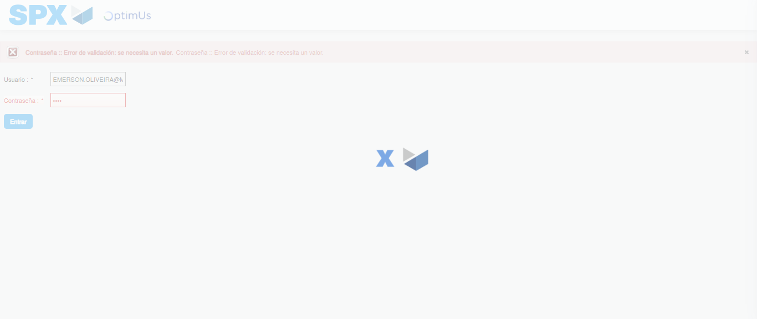Image file-name: QC_Testing-tc005_SPX_Dev5_Crear_Requisicion_Spot_Con_FAD_Tipo_Cobro_Project-1785975345680

Step 2 - Select to UEN and Access to Spot Buy Requisitions : UEN Correctly selected and Correct access
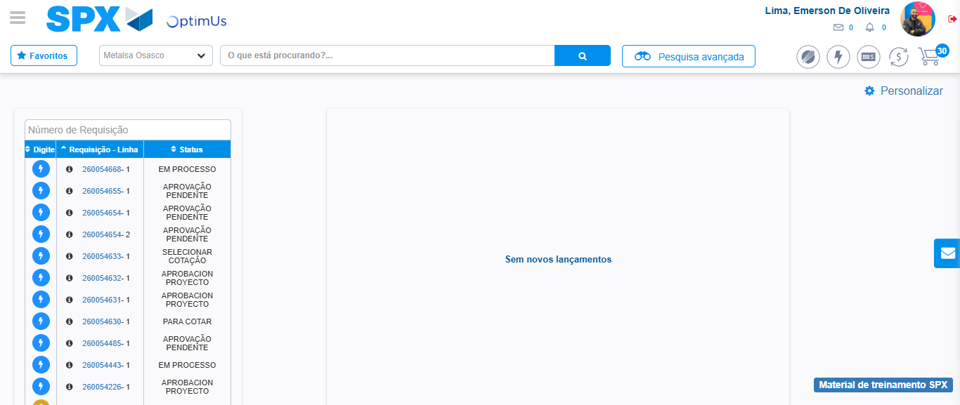Image file-name: QC_Testing-tc005_SPX_Dev5_Crear_Requisicion_Spot_Con_FAD_Tipo_Cobro_Project-1785975371289

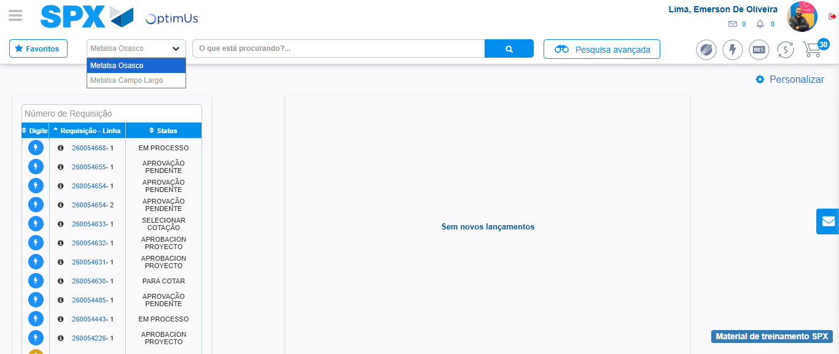Image file-name: QC_Testing-tc005_SPX_Dev5_Crear_Requisicion_Spot_Con_FAD_Tipo_Cobro_Project-1785975373767

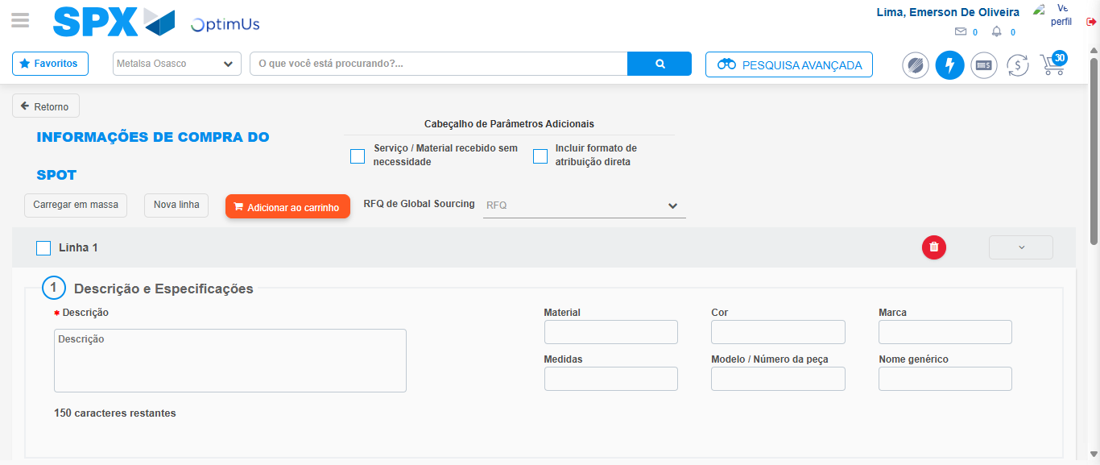Image file-name: QC_Testing-tc005_SPX_Dev5_Crear_Requisicion_Spot_Con_FAD_Tipo_Cobro_Project-1785975378723

Step 3 - Add FAD to Requisition: FAD Successfully Added
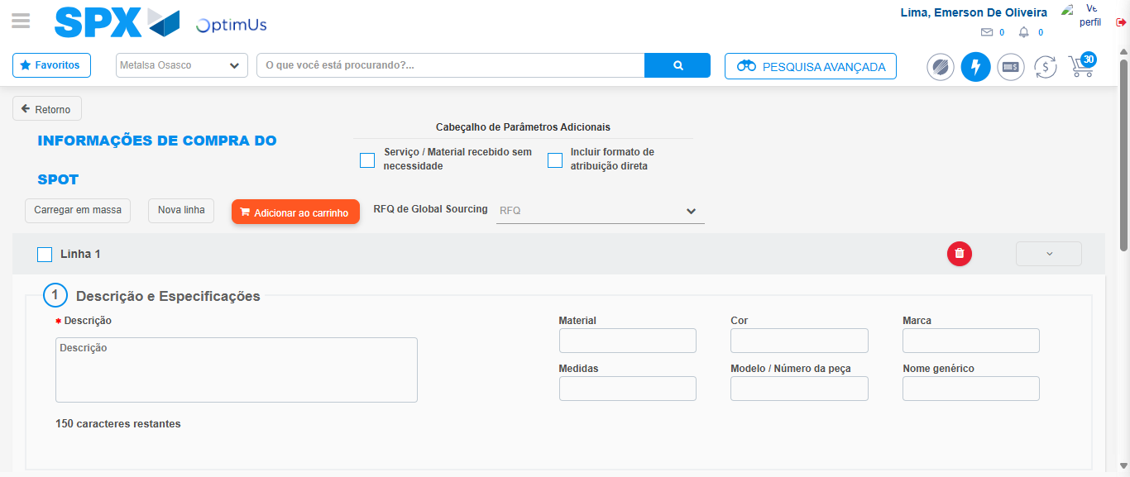Image file-name: QC_Testing-tc005_SPX_Dev5_Crear_Requisicion_Spot_Con_FAD_Tipo_Cobro_Project-1785975378968

Image file-name: QC_Testing-tc005_SPX_Dev5_Crear_Requisicion_Spot_Con_FAD_Tipo_Cobro_Project-1785975379177

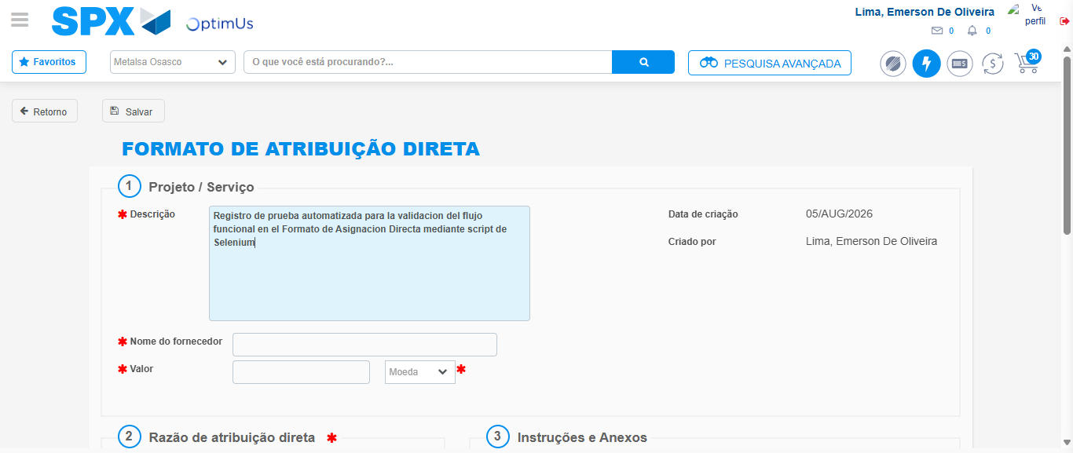Image file-name: QC_Testing-tc005_SPX_Dev5_Crear_Requisicion_Spot_Con_FAD_Tipo_Cobro_Project-1785975381903

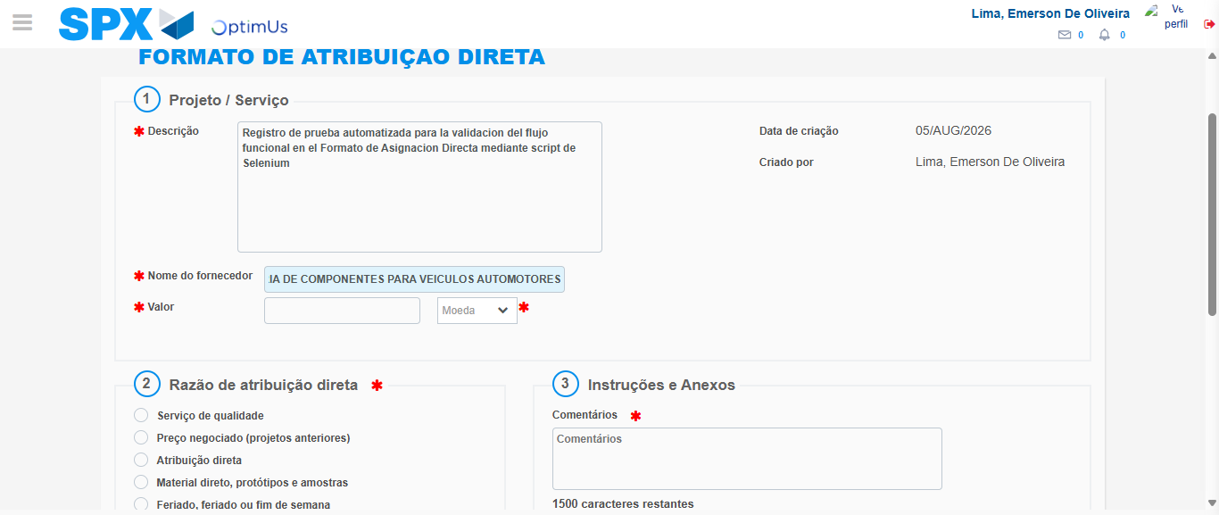Image file-name: QC_Testing-tc005_SPX_Dev5_Crear_Requisicion_Spot_Con_FAD_Tipo_Cobro_Project-1785975391046

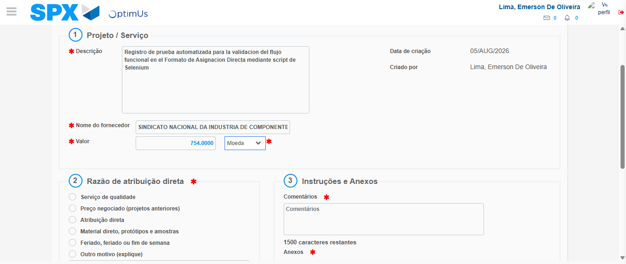Image file-name: QC_Testing-tc005_SPX_Dev5_Crear_Requisicion_Spot_Con_FAD_Tipo_Cobro_Project-1785975391436

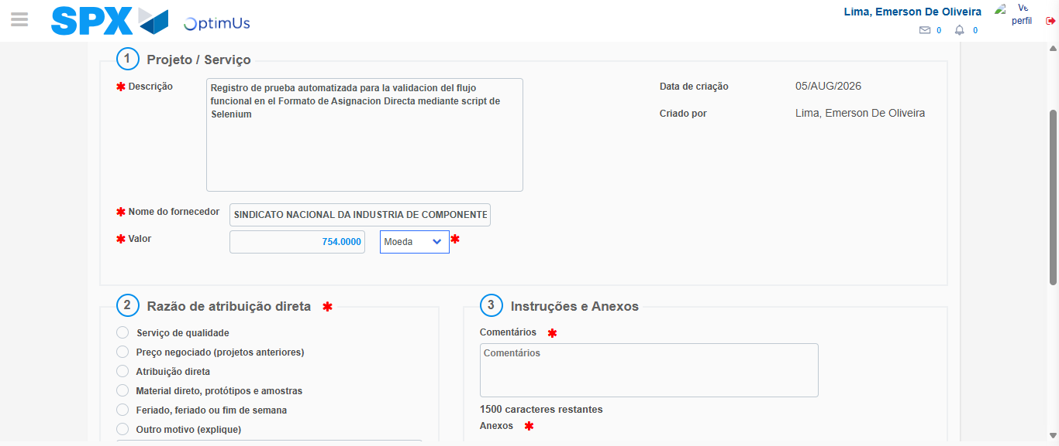Image file-name: QC_Testing-tc005_SPX_Dev5_Crear_Requisicion_Spot_Con_FAD_Tipo_Cobro_Project-1785975391646

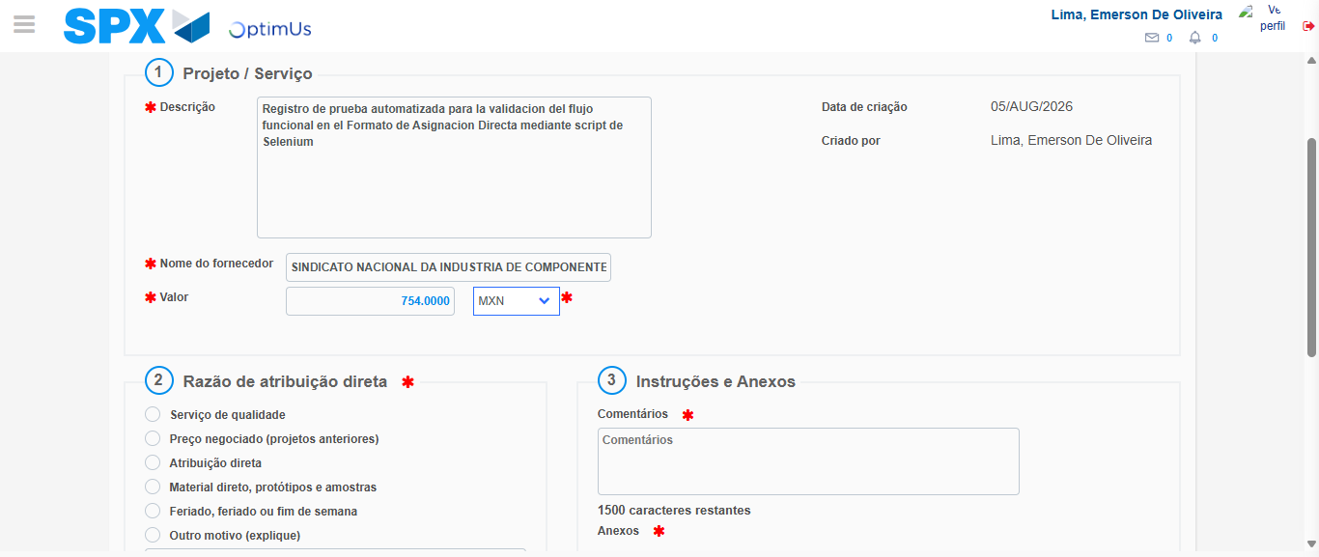Image file-name: QC_Testing-tc005_SPX_Dev5_Crear_Requisicion_Spot_Con_FAD_Tipo_Cobro_Project-1785975391991

Image file-name: QC_Testing-tc005_SPX_Dev5_Crear_Requisicion_Spot_Con_FAD_Tipo_Cobro_Project-1785975392159

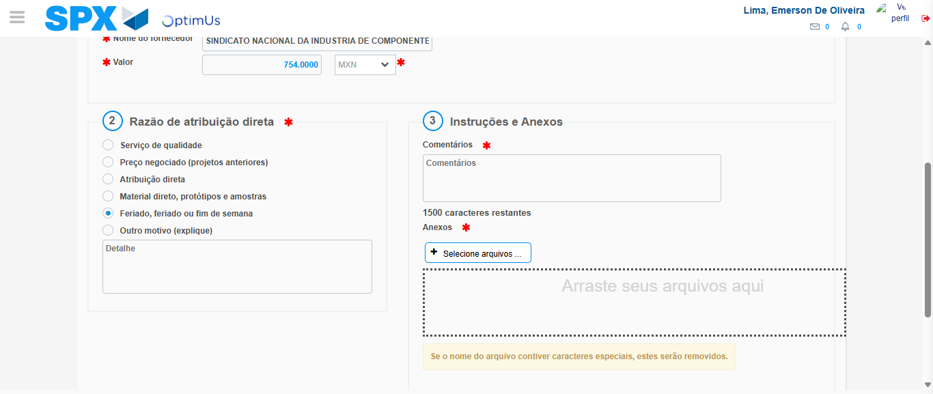Image file-name: QC_Testing-tc005_SPX_Dev5_Crear_Requisicion_Spot_Con_FAD_Tipo_Cobro_Project-1785975393031

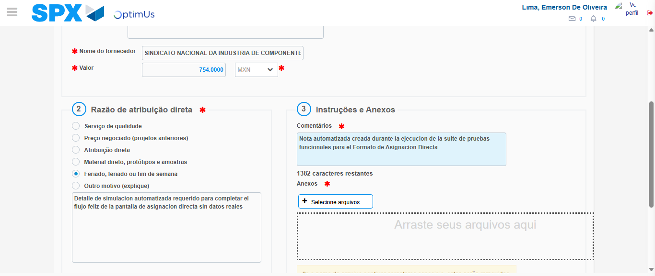Image file-name: QC_Testing-tc005_SPX_Dev5_Crear_Requisicion_Spot_Con_FAD_Tipo_Cobro_Project-1785975404145

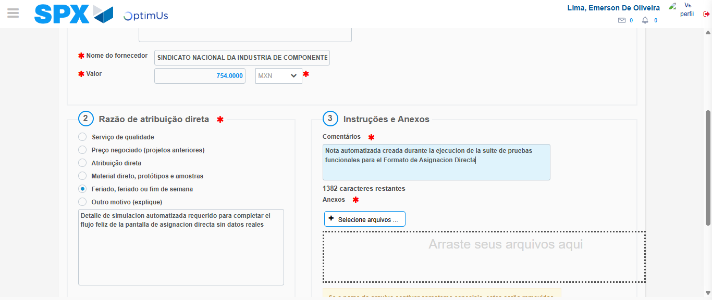Image file-name: QC_Testing-tc005_SPX_Dev5_Crear_Requisicion_Spot_Con_FAD_Tipo_Cobro_Project-1785975404761

Step 4 - Data Capture Spot Buy Requisition: Data captured correctly
Image file-name: QC_Testing-tc005_SPX_Dev5_Crear_Requisicion_Spot_Con_FAD_Tipo_Cobro_Project-1785975378968

Image file-name: QC_Testing-tc005_SPX_Dev5_Crear_Requisicion_Spot_Con_FAD_Tipo_Cobro_Project-1785975379177

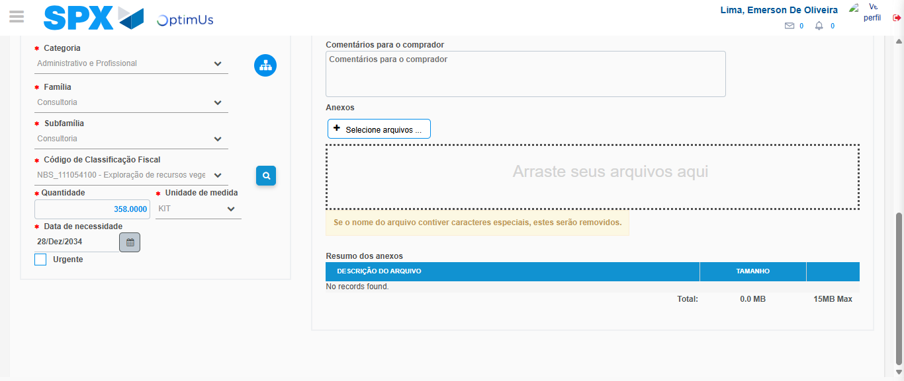Image file-name: QC_Testing-tc005_SPX_Dev5_Crear_Requisicion_Spot_Con_FAD_Tipo_Cobro_Project-1785975423169

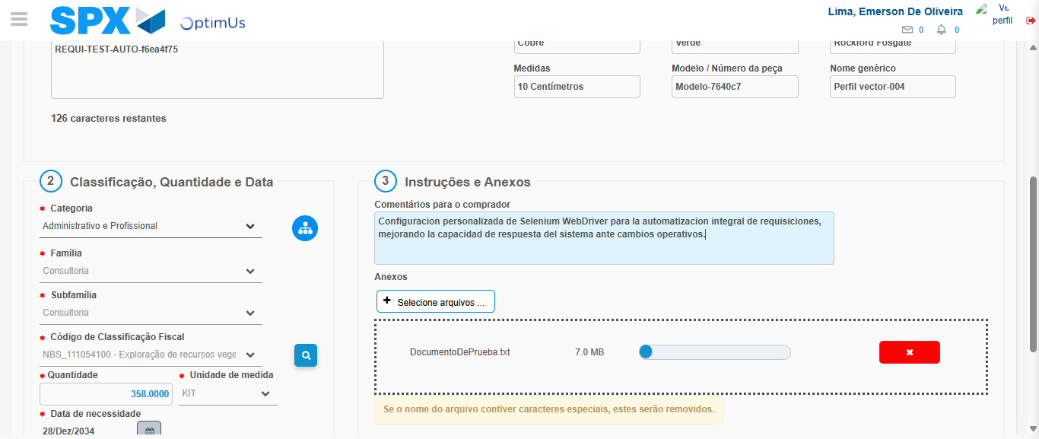Image file-name: QC_Testing-tc005_SPX_Dev5_Crear_Requisicion_Spot_Con_FAD_Tipo_Cobro_Project-1785975424101

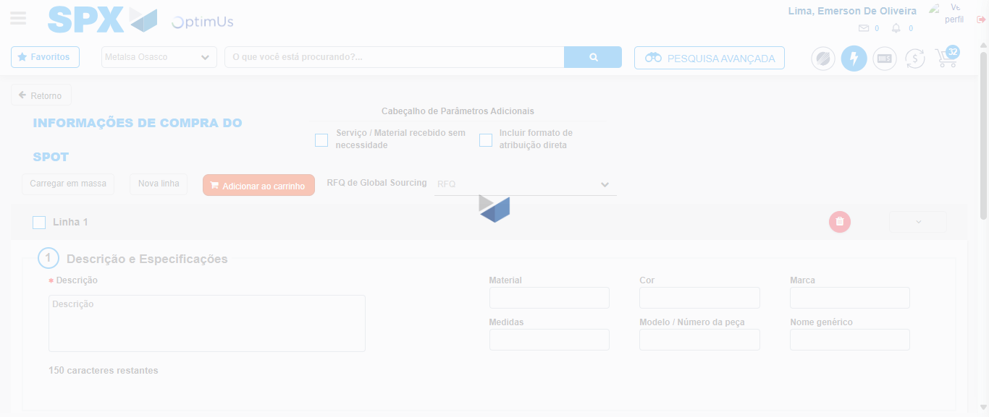Image file-name: QC_Testing-tc005_SPX_Dev5_Crear_Requisicion_Spot_Con_FAD_Tipo_Cobro_Project-1785975439034

Step 8 - Return to Main Page SPX : Return to Main Page SPX
Image file-name: QC_Testing-tc005_SPX_Dev5_Crear_Requisicion_Spot_Con_FAD_Tipo_Cobro_Project-1785975371289

Image file-name: QC_Testing-tc005_SPX_Dev5_Crear_Requisicion_Spot_Con_FAD_Tipo_Cobro_Project-1785975373767

Image file-name: QC_Testing-tc005_SPX_Dev5_Crear_Requisicion_Spot_Con_FAD_Tipo_Cobro_Project-1785975378723

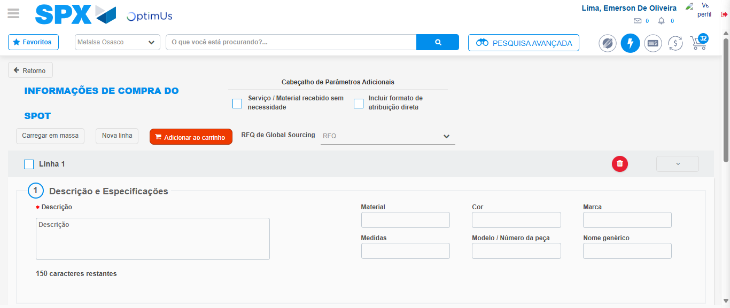Image file-name: QC_Testing-tc005_SPX_Dev5_Crear_Requisicion_Spot_Con_FAD_Tipo_Cobro_Project-1785975441324

Image file-name: QC_Testing-tc005_SPX_Dev5_Crear_Requisicion_Spot_Con_FAD_Tipo_Cobro_Project-1785975441523

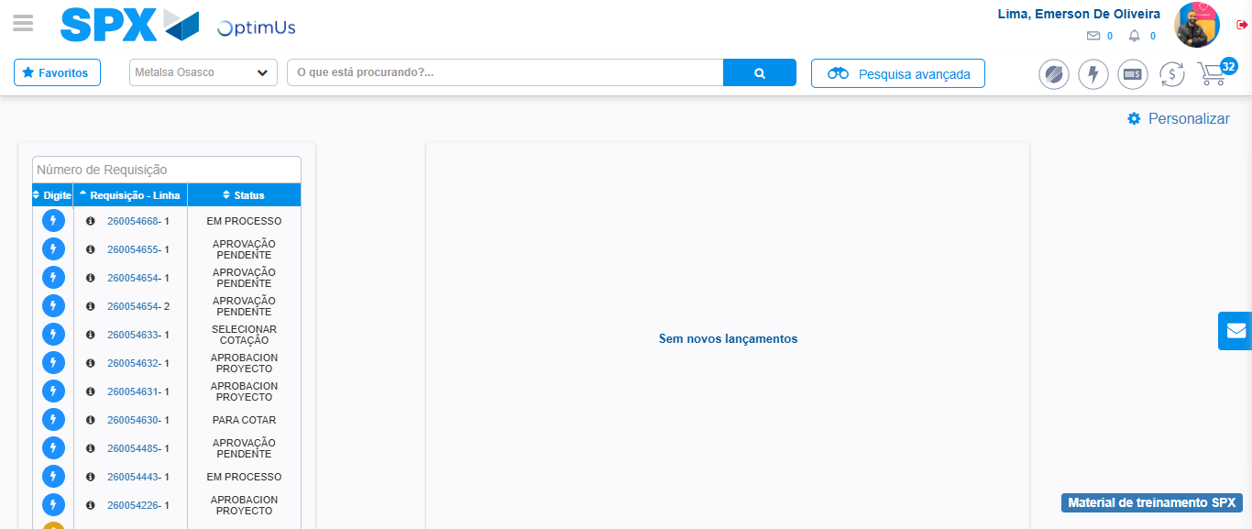Image file-name: QC_Testing-tc005_SPX_Dev5_Crear_Requisicion_Spot_Con_FAD_Tipo_Cobro_Project-1785975462681

Step 9 - Log Out : Log Out SPX
Image file-name: QC_Testing-tc005_SPX_Dev5_Crear_Requisicion_Spot_Con_FAD_Tipo_Cobro_Project-1785975462898

